Administrator:

Administer the Master Service Agreement in a Target Price Contract:
- “Chipped” away at inaccuracies on contractor daily time sheet charges and third party subcontractors – saving the client approximately 10-20% on a daily basis with final invoices totaling over $770 million.
- Perform daily analysis of field time sheets to verify completeness and accuracy for auditability.
- Oversee data entry personnel as they enter hours and equipment into spreadsheets used to quantify each weekly progress payment.
- Ensured Daily LEM charges matched what was on the signed off time sheets and what the contractor charged was considered accurate/acceptable in terms of the Master Service Agreement.
- “Groomed” contractor to provide accurate time sheets and LEMs so that charges best matched the work that was performed on the project.
- Ensured amendments to the “rules” of the MSA were in writing.

Equipment:
- Ensure contractor unit numbers match the piece of equipment and the piece of equipment matched the rates in the MSA. Worked with the inspection team to verify the accuracy of each piece of equipment. For example: a D6 dozer charged out as a D7- sometimes equipment gets charged out at a higher rate than what the machine actually is. The inspector verifies the machine being charged- from there I make sure it matches the assigned unit number and that number is linked to the appropriate rate. Over the course of 3 years, one incorrect unit price could translate into hundreds of thousands of dollars if not corrected on day one.
- Ensured the machine charged on the daily ticket matched the LEM and the machine’s rate is in the contract.
- Credits were applied where errors were recognized- even the inspector/foreman can get a machine type wrong.
- Ensured the same machine was not charged twice the same day and asked inspection staff to acknowledge when a machine was off the project, broken down or not working.
- Ensured the charged machine’s hours were not over the actual worked hours based on what hours the crew worked.
- Ensured machines were charged appropriately and not added to a crew for the sake of finding a “home”. For example- a post pounder was caught on the welding crew- welders do not build fences!

Manpower:
- Ensure personnel charged were correctly classified according to their role and the labor rate matched that of the Redbook/MSA rates. The inspection team would let me know what each person did and when he or she changed roles so the appropriate rate could be applied. Asked inspection team to relay when the worker was on site or away from the job as this could affect their overtime hours.
- Ensure manpower was charged according to Redbook rates and had appropriate hourly top ups as per union agreements
- Review Redbook/MSA rates prior to submission to client to ensure rates were accurate prior to the start of the project.

Third Party Charges:
- Ensure third party charges were applicable to the project.
- Ensure third party charges were not duplicated over the course of a project- saved client $750,000 in just one progress payment.
- Ensure charges were allocated to the appropriate project since the same contractor was working on several spreads and projects.
- Ensure third party charges were covered under the “small tools” and “consumables/expendables” agreement between contractor and client.

Lessons Learned About Target Price Contracts:

Equipment:
-Inexperienced equipment entry people- miss-classify equipment resulting in extra costs to the client. I.e. the difference between two types of hoes is $300/day- often this miss-classification is in favor to the contractor.
-Time sheets are pre-populated so it is up to the client to take off equipment that is not on site or being used. This is NOT the foremen’s responsibility as he thinks he is making money for the company. Unscrupulous timesheet populators have openly said “you can’t be too accurate” meaning there has to be padding somewhere.
-What equipment is considered chargeable? On site? Being used? Broken down? In the yard? Waiting to go to work? En-route to the job?
-Incentive for accurate timesheets is lacking.
-Equipment duplicates are found on a daily basis.

Hours For Small Tools charges:
-What hours are considered small tools? Do they include travel time, union top offs?
-Worked hours- how are they determined? Are rain days considered worked hours if personnel are sitting on the bus on the ROW? Workers travel on the bus, go to orientations, have sick days which are not worked, but no one can tell this is going on from the timesheets so small tools hours are billed. The inspection staff cannot tell what each worker did many times and the foremen do not pull the hours out.
-Jump hours? How do we know which ones those are? If jump hours are not worked and not pointed out, they could be considered “worked” if the foreman says they stayed out late
-Foremen get a 10-hour day regardless of what they do and likely not all of the hours are worked.
-Too complicated and messy of a system.

Workers:
-Foremen give jumps to whomever and for as many hours as they choose- no control
-Crews leave early on many days, but get paid for the full day and then some. Small tools are also charged on these hours even though they were not worked. Client is paying for zero production.
-Some personnel get an extra jump hour for driving people around or operating a certain piece of equipment as they are doing more than their job description. We do not have a say in how those hours are charged.
-People get hired on and get bonus hours based on what a “Foreman” has to say to the payroll people. Many times the contractor Construction Manager & Superintendent do not even know that the worker is getting paid “perks”.
-Charge out classifications often do not match the job role- based more on what the person is being charged out at- likely at an “increased rate”.
-There are not enough “Redbook” experts to correctly enforce “so-called” Redbook Rules. Often extra hours are tagged as “as per Redbook” yet no one can produce the clause.
-Missed hours are requested of the client but no one can prove the hour is required or that someone else got the hour through a payroll error.
-Payroll errors occur all the time and missed hours are charged back to the client. Refunded hours are extremely rare.
-Major lay offs often occur on a Monday- after an extra day of Sunday LOA has been paid.
-Personnel are given special incentives based on their situation (full foreman bonus paid even though foreman only worked for 2 weeks on the spread in question or a person is gone to a wedding so they get a week of LOA).

So Called “Foreman Rules”:
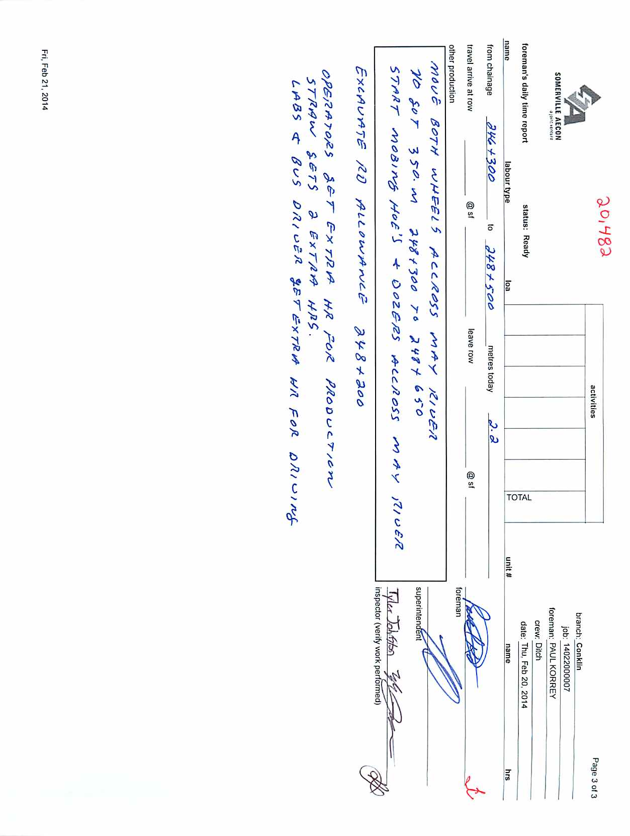

Third Party Invoices:
-Millions and millions of dollars found in duplications picked up by this office- contractor system has been a mess.
-“Day rate” items are attempted to be put through as a flow through- again contractor system is not accurate or the person submitting the invoices does not take the time to check for unit numbers and cross reference them with the equipment database.
-Invoices often do not have signatures of an authorized rep in the field to prove the transaction took place- chase signatures at a later date- often months later.
-Invoices are not checked for mathematical accuracy- often over charges are seen.
-Many times invoices do not contain substantial back up documentation to verify the charges.
-Sometimes 3rd party invoices are from other projects- many personnel are too inexperienced and do not know the difference between projects so an attempt at billing to the wrong project is made.
-Millions and millions were caught on this project…

Management:
-Billing personnel are data entry people- they do not know what the work is about or are able to see errors taking place
-Upper management does not see what is going on at the data level- they leave it up to the people who do not know the Contract to charge what they think is correct- often errors are paid by the client.
-Many times communication between client and contractor is ongoing without any input from the field level to determine what is or is not a legitimate expense or change order causing extra costs and/or mismanagement.

Overall, a client is relying on the contractor to determine what is an acceptable cost and therefore millions in errors can be made as the contractor personnel are inexperienced, unorganized or miss-informed on how the company makes a profit. To many contractor personnel, the term “target price” means that all expenses are billable and the more money that is spent-the better! Hard dollar jobs seem to project a different mentality since time spent on the project is now costing the contractor money and there is a difference in attitude from personnel.

